Contents

[Periphyton 3](#_Toc206408526)

[Introduction to Freshwater Slimy Stuff 3](#_Toc206408527)

[Scientist stuff 5](#_Toc206408528)

[PLAN - Vehicles, Staffing 6](#_Toc206408529)

[PLAN - Equipment List/Stock take 7](#_Toc206408530)

[PLAN - Run Guides and Site List 9](#_Toc206408531)

[PLAN – Survey and Printing Sample Labels 12](#_Toc206408532)

[No Data vs Flow Dashboard 13](#_Toc206408533)

[DATA COLLECTION - Survey123 16](#_Toc206408534)

[DATA COLLECTION - Sending Samples 17](#_Toc206408535)

[DATA PROCESSING - Lab Data Entry 18](#_Toc206408536)

[Data + KiEco 19](#_Toc206408537)

[DATA PROCESSING – QA/QC 20](#_Toc206408538)

[NEMS compliance 20](#_Toc206408539)

[Accessing Periphyton data from AGOL 21](#_Toc206408540)

[Army ID process 40](#_Toc206408541)

[Periphyton Data 43](#_Toc206408542)

[Peri data 101 43](#_Toc206408543)

[Getting Survey123/field data into KiEco 43](#_Toc206408544)

[End of year 44](#_Toc206408545)

[Getting chl-a/lab data into KiEco 44](#_Toc206408546)

[Getting peri data out of KiEco 47](#_Toc206408547)

[Preparing peri data requests 52](#_Toc206408548)

[Monthly KiEco import update? 57](#_Toc206408549)

[Survey 123 Connect 57](#_Toc206408550)

[Purpose 60](#_Toc206408551)

[1. KiECO 60](#_Toc206408552)

[1.1 Downloading Data from KiECO 60](#_Toc206408553)

[1.2 KiECO spreadsheet Setup 62](#_Toc206408554)

[1) Sample Metadata sheet: 63](#_Toc206408555)

[2) Unit and Spot Data sheet: 63](#_Toc206408556)

[3) Periphyton Cover sheet: 64](#_Toc206408557)

[4) Substrate Cover: 65](#_Toc206408558)

[2. Survey123 66](#_Toc206408559)

[2.1 Logging in 66](#_Toc206408560)

[2.2 Downloading survey 123 data 67](#_Toc206408561)

[2.3 Merging Survey 123 files 68](#_Toc206408562)

[2.4 Merged document 69](#_Toc206408563)

[Quality Assuring the Data 69](#_Toc206408564)

# Periphyton

## Introduction to Freshwater Slimy Stuff

**Project Objective:**

To monitor and report on the state of periphyton (algal) growth as an index of river health in relation to nutrients, and the aesthetic and amenity perceptions associated with contact recreation. To develop a regional model or series of catchment based models of the relationship between nutrients, flow regimes, and periphyton growth.

**Context:**

Periphyton is the community of slime and algae that grows on the river bed. Periphyton is believed to proliferate to nuisance levels when there are low flows, suitable velocities, stable substrates, nutrient enrichment, and high sunlight or water temperatures. The aim of the project is to enable modelling of the relationship between nutrient levels, flow regimes, and periphyton growth so as to better direct policies to control nuisance algae levels and to reduce effects of algae on river health and amenity values such as those associated with contact recreation. The project also allows policy effectiveness monitoring to be undertaken with regard to One Plan targets and national policy statement requirements for chlorophyll-a and algae coverage.

Note: This project also includes the regular monitoring of cyanobacteria which occurs simultaneously with periphyton monitoring.

All info can be found here \\file\herman\D\SR\03\01\Rivers\Periphyton monitoring

**How we do it**

Monitoring is carried out at predetermined sites on a monthly basis and is timed to coincide with State of the Environment water quality monitoring (that both the Science and Hydro teams conduct).

**SOP:**\\file\herman\E\WQ\03\05\Periphyton monitoring\Periphyton SOP Draft v3.docx

Below is the "usual" timeline we follow for the periphyton programme which is run over two calendar years. This notebook is intended to follow the timeline and all relevant information can be found in the corresponding page.

GANTT chart can be found here [\\file\herman\E\WQ\03\05\Handbook\GANTT chart](file://file/herman/E/WQ/03/05/Handbook/GANTT%20chart)

**Note:**between Dec-April each year, Week 4 is also used to undertake any other fieldwork (e.g. fish and macroinvertebrate monitoring or other projects that arise).

Wk 1 
Field Work 
Labels/field sheets 
Data Entry 
Send samples to lab 
Equipment checks 
Wk 2 
Wk 3 
Wk 4 

Year 1 
TASKS 
Organise Lab Contract, vehicles, staffing 
Get Equipment ready 
Check and update run guides 
Staff refresher/training (if required) 
Equipment stocktake 
Field data collection 
Collect samples for lab comparisons (—30) 
Send samples to the lab 
Data A 
Quarterly reporting 
State and trend reporting 
Year 2 

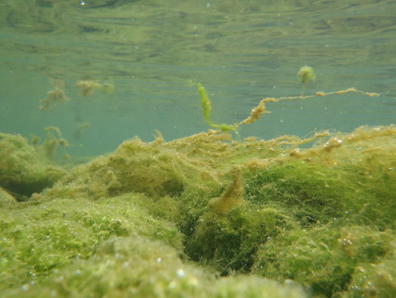

## Scientist stuff

All information regarding this programme can be found here [\\file\herman\E\WQ\03\05\Periphyton monitoring](file://file/herman/E/WQ/03/05/Periphyton%20monitoring)

The periphyton program requires a procurement process for chla sample processing (note this contract includes the monthly peri samples and the annual peri samples collected with invertebrate monitoring). Procurement and contract for the 2023-2024 FY can be found here:

* \\file\herman\D\SR\01\01\Procurement\Rivers and streams\2023 - 2024\periphyton Chl\_a

Penny Harrison from Cawthron is the contact

[Penny.harrison@cawthron.org.nz](mailto:Penny.harrison@cawthron.org.nz)

This purchase order is one big one for the year and receipts are noted in the PO tracking spreadsheet.  2023-2024. The **purchase order number is 1386** and the details of this can be found in datascape.

The scientist makes any PO's needed for extra gear (e.g. bathyscopes, pottles, stickers etc.) but the RA's order this (info on ordering more gear can be found in Plan – Equipment List page.

Every two months we schedule a monitoring meeting (note this info is also in WQ monitoring section) regarding all things monitoring with Darren Bentley-Hewitt, David Brown, Pita Kinaston and the environmental monitoring scientist attending (sometimes the groundwater scientist as well). These are set up and led by the Enviro scientist.

General agenda includes:

* Health and safety
* Lab
* Compliance
* General business
* Follow up anything from the last meeting

Meeting minutes can be found here [\\file\herman\E\WQ\03\05\Monitoring Meeting Minutes](file://file/herman/E/WQ/03/05/Monitoring%20Meeting%20Minutes)

**Run optimisation (note this is also in WQ section)**

Work began in 2022 to optimise the monthly peri/WQ runs that science and hydro undertake. The aim was to reduce CO2 emission (by removing vehicles from the road for those runs, or allowing them to be available for other activities), increasing health and safety by double manning runs and increasing knowledge transfer between hydro and science teams.

Information can be found here [\\file\herman\E\WQ\03\05\Periphyton monitoring\Run Optimisation 2022](file://file/herman/E/WQ/03/05/Periphyton%20monitoring/Run%20Optimisation%202022)

 As of March 2023 run optimisation for the northern runs (Whangaehu, Whanganui and West coast) has not taken place.

## PLAN - Vehicles, Staffing

**Vehicles**

There are two dedicated Science vehicles (Ford Ranger Ute QAD858 & PFS711) which can be used for any fieldwork. Over the summer period, there is a third vehicle available (shared with the Freshwater team who have it over winter (RAE464)). Note: additional vehicles will be necessary for contact recreation over the summer swim period, and should be organised with Assets well in advance.

Vehicles can be booked using the ERoad booking system which can be found in the Horizons Desktop Apps (see below). Usually the extra vehicle needs to be a 4WD vehicle as not all pool cars are suitable for all sites.

**Staffing**

Currently there are three full time research associates (RA's) with one other available more over summer. The environmental Scientist directs works, but is also able to support field work where necessary.



## PLAN - Equipment List/Stock take

If you need to order more equipment (e.g. pottles) our preferred suppliers can be found here \\file\herman\D\SR\03\01\Admin\Supplier List. Essentially just ring the company and order however many things you need to order – make sure to confirm the price including freight and GST so that Environmental scientist can adjust the PO. Environmental scientist will also provide you with a PO to give to the company. Some things (e.g. toothbrush, scrubbing brush etc) can be purchased from the supermarket using Environmental scientists work card.

**Periphyton Specific Gear List**

* Bag
* Pottles (large and small)
* Pottle lids (large and small)
* Ice cream container
* Scrubbing brush
* Toothbrush
* Yellow lid
* Washer bottle
* Big lunchbox container
* Sample stickers
* iPad
* Bathyscope
* Chilly bin
* Ice-packs
* Any keys for sites (e.g. 636 key for STP's and Ruapehu STP key)

**General Gear List**

* Waders (chest and/or thigh)
* Gloves
* Disinfectant for wastewater samples
* Sampling pole
* High Viz rain jackets, vests, shirts
* PFD
* PLB
* Throw Bag
* Alcohol gel/hand sanitiser
* Shovel
* Spare periphyton pottles
* Spare WQ bottles
* Spare blank stickers
* Paper field sheets/blank paper
* Measuring tape
* Black disc
* Clarity tube
* Paper towels
* Spare pens/pencils/vivids
* 4WD vehicle equipped with a VHF radio
* Sunscreen

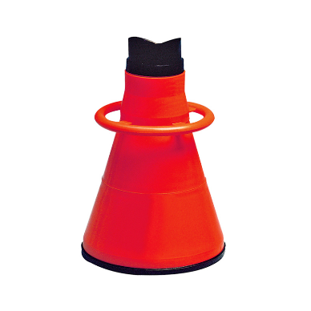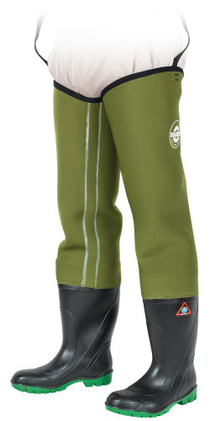

## PLAN - Run Guides and Site List

**Periphyton Run Guides**

These are updated annually (June or July) and are stored in the [Hydro Catchment Data Management System](http://tqm.horizons.govt.nz/hydrology/) which is easily accessible in the field in case you forget your run guide. If you do make any changes outside the annual review be sure to update the version number and send it to Darren Bently-Hewitt know so he can update the OMS. Changes can be made to the Word documents which can be found here \\file\herman\D\SR\03\01\Rivers\Periphyton monitoring\Periphyton run guides\Updated run guides 2024.

**Week 1:**

* Ohau Waikawa Runs (both on the same day)
  + [Ohau Waikawa Run 1](http://tqm.horizons.govt.nz/hydrology/SOPs/cd_om_15.7_appendix_24_SoE%20-%20Ohau%20Waikawa%20SoE%20Run%201.pdf) (which has both periphyton and SoE/WQ components and typically team up with a hydro person for this run)
  + [Ohau Waikawa Run 2 and Ohau Waikawa Estuary](http://tqm.horizons.govt.nz/hydrology/SOPs/cd_om_15.7_appendix_25_SoE%20-%20Ohau%20Waikawa%20SoE%20Run%202.pdf) (which has both periphyton and SoE/WQ components)
* [Upper Rangitikei](http://tqm.horizons.govt.nz/hydrology/SOPs/cd_om_15.7_appendix_30_Periphyton%20-%20Upper%20Rangitikei.pdf)(which has both periphyton and SoE/WQ components)
* [Lower Rangitikei](http://tqm.horizons.govt.nz/hydrology/SOPs/cd_om_15.7_appendix_31_Periphyton%20-%20Lower%20Rangitikei.pdf) (which has both periphyton and SoE/WQ components) ([East Coast](http://tqm.horizons.govt.nz/hydrology/SOPs/cd_om_15.7_appendix_40_Coastal%20and%20Estuary%20-%20East%20Coast.pdf) WQ run on the same day)

**Week 2:**

* Upper Manawatu Runs (both on the same day):
  + Upper Manawatū Run 2 (with hydro; both periphyton and WQ)
  + Upper Manawatū Discharge (aka Run 3) (with special projects; both periphyton and WQ)
* Mangatainoka Runs (both on the same day)
  + Mangatainoka SOE Run (With hydro; which has both periphyton and SoE/WQ components)
  + Mangatainoka cyanobacteria Run (which has both periphyton and SoE/WQ components)
* Pohangina (with hydro; both WQ and periphyton)
* [Oroua](http://tqm.horizons.govt.nz/hydrology/SOPs/cd_om_15.7_appendix_36_Periphyton%20-%20Oroua.pdf) (with hydro)([Foxton Estuary](http://tqm.horizons.govt.nz/hydrology/sops/cd_om_15.7_appendix_42_Coastal%20and%20Estuary%20-%20Foxton%20Estuary.pdf) run on the same day) (both runs have WQ and peri on them)

**Week 3**

* [Whangaehu](http://tqm.horizons.govt.nz/hydrology/SOPs/cd_om_15.7_appendix_37_Periphyton%20-%20Whangaehu.pdf)
* [Whanganui](http://tqm.horizons.govt.nz/hydrology/SOPs/cd_om_15.7_appendix_38_Periphyton%20-%20Whanganui.pdf) ([West Coast](http://tqm.horizons.govt.nz/hydrology/sops/cd_om_15.7_appendix_41_Coastal%20and%20Estuary%20-%20West%20Coast.pdf) WQ run on the same day)

**Week 4**

Office week/pick up any other fieldwork that needs doing outside of periphyton monitoring (e.g. macroinvertebrates, fishing or didymo).

**Site List**

As of August 2025 there are 62 periphyton sites. A full site list for all monitoring programmes can be found here:

\\file\herman\D\SR\03\01\Rivers\Site Metadata

Site metadata folder contains an excel spreadsheet with data for all programs – the data is required to be kept accessible by NEMS – living document so keep updating when data is collected.

There are also photos pulled from survey 123 for all the site at each monitoring event.

**Single or Double Person Runs**

Below is a list of the runs and the number of staff required for each run.

|  |  |  |  |
| --- | --- | --- | --- |
| **Run Name in Sampler** | **How many people** | **How many Aquatrolls** | **Approx starting time** |
| SOE - Ohau Waikawa Run 1 | Double (1x Sci and 1x Hydro) | 1 - Freshwater | 8am |
| SOE - Ohau Waikawa Run 2 (and Estuary - Ohau Run) | Single (1x Sci) | 2 – Coastal and Freshwater | 8am |
| Periphyton - Rangitikei (Upper Rangitikei) | Single (1x Sci) | 1 - Freshwater | 7:30am |
| Periphyton - Lower Rangitikei | Single (1x Sci) | 2 – Coastal and Freshwater | 8am |
| Coastal - East Coast | Single (1x Sci) (WQ only) | 2 – Coastal and Freshwater | 8am |
| SOE - Upper Manawatū Run 2 | Double (1x Sci and 1x hydro) | 1 - Freshwater | 8am |
| Discharge - Upper Manawatū Run 3 | Double (1x Sci and 1x Special projects) | 1 - Freshwater | 8am |
| Cyanobacteria - Mangatainoka Cyanobacteria Run | Double (2x Sci) | 1 - Freshwater | 8am |
| SOE - Mangatainoka Run | Double (1x Sci and 1x hydro) | 1 - Freshwater | 8am |
| SOE - Pohangina | Double (1x sci and 1x hydro) | 1 - Freshwater | 8am |
| SOE - Oroua | Double (1x Sci and 1x hydro) | 1 - Freshwater | 8am |
| Estuary - Foxton Estuary | Single (1x Sci) | 2 – Coastal and Freshwater | 8am |
| Whangaehu (periphyton only, not in sampler) | Double (2x Sci) | None | 7:30am |
| Periphyton - Whanganui | Double (2x Sci) | 1 - Freshwater | 6:30am |
| Coastal – West Coast | Single (1x Sci) (WQ only) | 1 - Coastal | 8am |

In 2022, we undertook an exercise to optimize WQ and peri runs with hydro with the aims of reducing CO2 emissions (by either removing vehicles entirely from runs or by shuffling sites to prevent teams visiting the same site on the same day), double-man runs, and increase hydro/sci cross pollination of information and knowledge. Information can be found here: \\file\herman\D\SR\03\01\Rivers\Periphyton monitoring\Run Optimisation 2022

## PLAN – Survey and Printing Sample Labels

Generating QR codes for samples

With the end of CADDIS, generating QR codes requires using this link: <https://qrcodegenerator.horizons.govt.nz/>

This app looks at KiEco for the selected sampling programmes, so monitoring programmes must be entered into KiEco before QR codes can be generated.

The client code is usually HRC, but can be added if different (e.g. TDC).

The survey code can be confirmed with the relevant scientist (WQU – for Periphyton), and the month is the sampling month rather than the generating month (I.e. making QR codes in January for sampling in February, the month will be February).

The most likely error will be selecting the wrong sampling programme, as it pulls all monitoring programmes from KiEco. Missing sites from a programme will need to be added manually in KiEco. Selecting "print" will print the sticky labels.

**Printing Periphyton Sample Labels**

Damaged or lost stickers can be replaced by selecting "reprint" in the top-left menu. Re-enter the relevant dates, etc to access the same monitoring programme, and select the sites you need to re-print. You can also select the printing position of the labels in a subsequent page to save using a whole label sheet for only one or two labels.

When printing the stickers scroll to the bottom of the page and hit print

HRC2023WQU00804 
Mangatainoka at Larsons road 
Date: 
Sampler 
Back 
Format 
Print 

DO NOT PRINT DOUBLE SIDED!

You will need to go into printing preferences select printer either Arena level 2 or science copier (at regional house) in put tray need to be changed to bypass Tray. The stickers need to be loaded face down onto the tray

Tip: Print stickers with setting 'actual size' to avoid the sample numbers being cut off at the top

Printing Preferences 
One Click Presets Basic 
Current Setting 
Cocument Size : 
(210 x mm) 
Print On: 
Same as Original Size 
Input/output 
Finishing LayoutEdit 
Job Type: 
Normal Prin t 
Cocument Size : 
AA (210 x 297 mm) 
pr,nto,-, 
Same as Original Size 
Inpu ray: 
Bypass Tra y 
Color Mode: 
Color 
Layout: 
00 ff 
Staple: 
(0 
Text/'vVa termark 
aper Size.. 
Image Quality Others 
Copies:(l to 999) 
@Portrait 
C) Landscape 
Paper Type: 
Plain & Recycled 
2 sided: 
ReduceEnIarge: 
Fit to Paper Size 
Register Current Settings... 
Se tbngs Summary 

## No Data vs Flow Dashboard

As of January 2023 the No Flow Dashboard can be used to make decisions about which periphyton sites can and cannot be gone to. This dashboard was created to help reduce the amount of driving around un-necessarily (mainly over the winter months) when we are unable to take a periphyton sample because the rivers are high. This dashboard sets out which sites are on which runs and helps us to make decisions about which runs that we don’t have to go to.

Link to the dashboard:

<http://tqm.horizons.govt.nz/Hydrology/Science/PeriphytonSampling/PeriphytonDashboard.html>

 Below is the link to the memo which has been written up to help make our decisions and give background information on why this has been created:

\\file\herman\D\SR\03\01\Rivers\Periphyton monitoring\No data vs flow dashboard

**Decision making**

The memo sets out how decision making will take place using the new dashboard. When all sites on a run are red, it is acceptable to not go on the run and in the comments explain that due to the dashboard being all red you didn’t have to go on the run and fill out the survey with no data's. If the run has some sites that are maybe and some sites that are red, you are able to go on the run and get the sites that you are able to. And obviously if there are sites that are green you can go on the run and sample!

 Below is a screenshot of the main dashboard when you first open it. The run names are along the top, with each of the sites on that run listed below it. You are able to click on each site to bring up a more detailed record of the flow levels at that site and all previous sampling events.

Periphyton Flow Dashboard | 17 February 2023 11:53 
Map 
New th 
Manawatu 
Whongonui 
Wha ganui 
Lower Rangitikei 
Upper Rangitikei 
Mangatainoka Run 1 Cyanobacteria Mangatainoka Run Ohau Waikawa 1 
Ohau Waikawa 2 
Oroua 
Pohangina 
Upper Manawatu Run 2 
Whangaehu 
Show 20 v entries 
Site 
Makakahi at DOC Reserve 
Makakahi at Hamua 
Mangatainoka at Larsons road 
upper Manawatu Discharge Run Foxton Run 
Max Stage Sampled 
Current Stage 
'Hawke's 
gay 
Ha tings 
2234 
2008 
1025 
1673 
2122 
2102 
2102 
704 
1756 
704 
Sampling Status 
Maybe 
No 
Maybe 
No 
Maybe 
Search: 
Link 
Makakahi at DOC Reserve 
Makakahi at Hamua 
Mangatainoka at Larsons road 
Mangatainoka at Pahiatua Town Bridge 
Mangatainoka at Putara 
Poriru 
Lo er utt 
Wellington 
L ton 
Mor/borj/_i h 
Sampling Status 
Yes 
No 
Maybe 
Mangatainoka at Pahiatua Town Bridge 
Mangatainoka at Putara 
Showing 1 to 5 of 5 entries 

Here is the more detailed record of Makakahi at DoC Reserve which shows that it is currently in the maybe range of sampling. There have been a couple of samples taken at the current flow (most probably outliers), but also some no datas, so best off to go to the site and see if you are able to get a sample.

Sampling Status 
current stage: 2097 mm @ 2023-02-17 10140:OO 
Sample Status 
No Sampling 
Potential Sampling 
Go Sampling 
Plots 
Sampling Box Plot 
3200 
3000 
2800 
2600 
E 2400 
2200 
2000 
1800 
1600 
1400 
No Sample 
stage Threshold (mm) 
> 2234 
2234 - 1541 
< 1541 
Sample 
% ot Time 
6.2 
15.0 
79.0 
No Sample 
Sample 

Due to the fact that most runs are now double manned with hydro, if after a rainfall event you are unable to get into any sites, hydro may just be able to go out by themselves to get the WQ samples. This decisions needs to be made in conjunction with the hydro team so that everyone is on the same page. Sometimes when the river levels are really high and we can't get into any of our periphyton sites, we may still be required to go out with hydro to double man the run for safety reasons. An example of this was sampling during Cyclone Gabrielle, when we couldn’t get any samples but still double manned all runs for safety.

**Making Changes to the Periphyton Dashboard**

What changes can we make?

1. Add monitoring sites
2. Add or remove periphyton runs
3. Change site or run names
4. Put sites into different runs

Firstly you will need R-studio on your computer. If you have TS-Farm talk to IT about your options. Otherwise you may need a PC to run R-studio.

If you are not adding a new run or changing the run name R-studio won't be needed.

Follow the instructions Amy has laid out here:

[\\ares\Science\PeriphytonSampling\Code\Instructions\_Periphyton Sampling Flow Threshold Dashboard.docx](file://ares/Science/PeriphytonSampling/Code/Instructions_Periphyton%20Sampling%20Flow%20Threshold%20Dashboard.docx)

You will also need these documents open to make your changes   
[\\ares\Science\PeriphytonSampling\Code\Site\_Switch\_2.csv](file://ares/Science/PeriphytonSampling/Code/Site_Switch_2.csv)

[\\ares\Science\PeriphytonSampling\Code\PeriphytonDashboard.Rmd](file://ares/Science/PeriphytonSampling/Code/PeriphytonDashboard.Rmd)

## DATA COLLECTION - Survey123

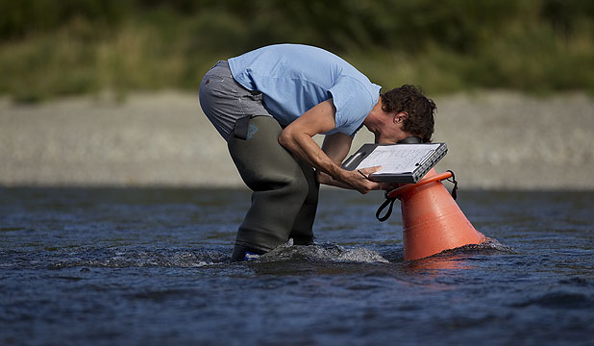

**Before Leaving the Office**

Double check you have all the right gear before you leave.

Make sure you have a check-in buddy that knows what run you are doing/sites visiting (and where to access the run guide) and what time you will be back. Please remember to txt them when you return safely.

Also start the GetHomeSafe App to track your location throughout the day. Log into [GetHomeSafe](https://www.gethomesafe.com/" \t "_blank) to see your activities. Along with setting up GetHomeSafe, take an InReach unit with you. Another app, Earthmate can be downloaded alongside the InReach units, which can be used to send messages to people to let them know you are ok or alternatively not. – see hydro if issues connecting.

Survey 123 downloaded and logged in – correct survey downloaded.

**Instructions on how to fill out a survey in Survey123**

- Open survey 123 app and sign in. Open the periphyton survey and fill out as prompted. Using the general notes add anything that is not normal e.g. if sampling was done further upstream, cattle in water, the river was too high for a survey to be carried out you might put 'River flooded, no views or chl a collected'.

- Once done press the tick in the bottom right corner and send the survey. If you are out of range, it will save in the *Outbox* so remember to send the surveys. The surveys are device specific so if completed but not sent on a mobile phone the survey can’t be accessed on an iPad.

- Luke has created a tool that emails at the end of the month to check if there’s any missing surveys in the database.

## DATA COLLECTION - Sending Samples

Try to send all samples in the afternoon so that they don’t sit outside all day and defrost. Make sure to ask Print requests for an overnight courier to either Cawthron (Nelson) or NIWA (Christchurch) and put plenty of slikka pads into the chilly bin. DO NOT send samples on a Thursday, Friday or before a public holiday in case they don't make it to the lab.

Get a purchase order from the Environmental Monitoring Scientist – enter it in the correct field ('order')

2023-2024 (financial year) PO# is 1386

2024-2025 (financial year) PO# is 10225

2025-2026 (financial year) PO# is 17512

1. When printing monthly samples a checklist is made including Site ID and site name.
   * Sample checklist is download at the time of QR code creation and is stored here:
     + [\\file\herman\D\SR\03\01\Rivers\Periphyton monitoring\Monthly](file://file/herman/D/SR/03/01/Rivers/Periphyton%20monitoring/Monthly) stickers
   * Print out,
   * Use checklist to go through frozen samples filling in the dates.
   * Add dates into spreadsheet.

1. Copy and paste the first 3 columns into the Excel sheet (Cawthron Submissions template) \\file\herman\D\SR\03\01\Rivers\Periphyton monitoring\Cawthron Submission\Submission 2024

You will need to change 'SampleType' and 'Analysis required' for any sites that haven't been sampled. Delete 'Water' and 'Chyl a' and write 'No Sample'.

1. Copy and Paste all 5 Columns into the word document (Cawthron Submissions template)

\\file\herman\D\SR\03\01\Rivers\Periphyton monitoring\Cawthron Submission\Submission 2024

1. Print a copy of both word document and excel sheet, these need to go in the chilly bin (in a Ziplock bag) with the samples.
2. Email Cawthron ([lab@cawthron.org.nz](mailto:lab@cawthron.org.nz)) to let them know that the monthly samples have been sent and that they should expect them the next day. Attach both the relevant spreadsheet and word document to the email.
3. Visit the printing room with this address: \\file\herman\D\SR\03\01\Rivers\Periphyton monitoring\Cawthron Submission

To print a courier ticket. Will be a small/medium chilly bin size. Overnight postage. - (summer – large bin – 15kgish)

[Sign In - NZ Couriers Identity](https://identity-nzc.gosweetspot.com/Identity/Account/Login?ReturnUrl=%2Fconnect%2Fauthorize%2Fcallback%3Fclient_id%3Dnzc.gosweetspot.com%26response_type%3Dcode%26scope%3Dprofile%2520email%2520openid%2520offline_access%26redirect_uri%3Dhttps%253A%252F%252Fnzc.gosweetspot.com%252FAccount%252FOidcLoginReturn%26state%3D8q3T0tUs%252BdT96xVt5%252FxDqECOF6LfociJomuey0f9QPQ%253D;%252Fship%253Fdestination.countrycode%253DNZ%2526ReturnLabelStockType%253Dundefined%26nonce%3D8q3T0tUs%252BdT96xVt5%252FxDqECOF6LfociJomuey0f9QPQ%253D%26response_mode%3Dform_post)

## DATA PROCESSING - Lab Data Entry

Cawthron and NIWA will email you the results. In general they send the results when they are finished with them, but this is meant to be within 2 weeks. This is loosely held to and not followed up on but in future we may need to enforce this a little more so that data is here and ready to go when we want it to be.

**Cawthron**

Save all of the attached documents (pdf, txt and csv) as *Month Year* (e.g. February 2020) into the relevant years folder (make a new folder for the correct year if it isn't already there) [\\file\herman\D\SR\03\01\Rivers\Periphyton monitoring\Periphyton](file://file/herman/D/SR/03/01/Rivers/Periphyton%20monitoring/Periphyton) Sample Results

## Data + KiEco

1. <http://tqm.horizons.govt.nz/Hydrology/Science/dashboard_map.html>
2. Go to KiEcoTools
3. Prepare Data for Entry tab
4. Monthly periphyton monitoring
5. Field Data

\\file\appdata\Wiski\LIVE

1) The first is an Aquatic biomonitoring user log in. This one can view everything in the database and (I think) export data at a later date, but cannot edit anything:

Username: AB\_user

PW: Fish\_are\_Friends\_2022

2) The second is aquatic biomonitoring data admin. This user can view all data but only edit the aquatic biomonitoring data (i.e. they can’t accidentally edit the EcoBase biodiversity data).

Username: data\_admin\_ab

PW: 2022\_Just\_Keep\_Swimming

Home 
Gallery 
Map 
Scene 
Groups 
Content 
Organization 
Q 
n 
Overview 
Izzie Hodgson 
IHodgson_HorizonsRC 
Visual Assessment of Periphyton and Cyanobacteria 2022_September2023 
Edit thumbnail 
Add to Favorites 
Description 
Add a brief summary about the item. 
CSV collection by IHodgson_HorizonsRC 
Item created: 2 Oct 2023 Item updated: 2 Oct 2023 
Number of downloads: 0 
Ed it 
Ed it 
Ed it 
Usage 
Download 
IJpdate Da 
Share 
Metadata 
Item Information 
Settings 
O Learn more 
High 
Add an in-depth description of the item. 
Terms of Use 
Add any special restrictions, disclaimers, terms and conditions, or limitations on using the item's content. 
Top Improvement: Add a summary 
Details 

## DATA PROCESSING – QA/QC

At the end of every month in the 'off' week, the data that was collected during that month needs to be QA'd and QC'd. The instructions document here \\file\herman\D\SR\03\01\Periphyton\QA

The data is QC'd according to the Periphyton NEMS

## NEMS

[Periphyton-v1.0.1.pdf](https://bucketeer-54c224c2-e505-4a32-a387-75720cbeb257.s3.amazonaws.com/public/Documents/Periphyton-v1.0.1.pdf)

Horizons monitoring protocol meets NEMS

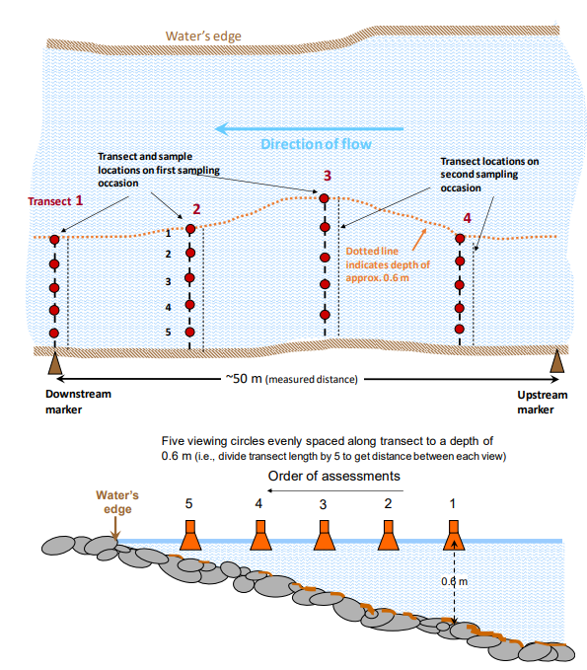

All of these changes have been put into the field and office manual for periphyton and can be found in the link below:

\\file\herman\D\SR\03\01\Periphyton\NEMS 2020 guidelines\Periphyton Office and Field Manual.docx

The file below is where we have saved all of the documents that have to do with the change in NEMS regulations:

Monday 11/07/2022

NEMS compliant changes have now been made to ensure we reach QC600

These changes include:

* Collecting 10 rocks over two transects
* Including wadeable width in our survey
* Extending the reach length to 50m for every site (within reason)
* Cover for the bathyscope to prevent damage to the viewer
* Estimate the flow state (low, medium or high) for each site
* Percentage of sediment estimate for each view

The Office and Field Manual can be found here:

\\file\herman\D\SR\03\01\Periphyton\NEMS 2020 guidelines

## Accessing Periphyton data from AGOL

**NOTE: further down towards the bottom of this page includes how to get photos out of survey123 if you ever need them**

**Downloading survey 123 data from Arc GIS online (AGol)**

1. In google search engine go to the arc gis online website login page
2. Click “sign in”

To access survey 123 periphyton data:

1. Click on the “content” link at the top of the page
2. Click on the “My Organization” link in the blue banner
3. In the search bar type in what you are looking for, - e.g. periphyton or macroinverts.
4. Once you have selected the file you are after select “export data” on the right hand side of the page
5. Click the drop down and select “export to CSV file”

Overview 
Visualization 
Open in Map Viewer 
Open in Scene Viewer 
Open in ArcGlS Desktop v 
Export Data v 
Details 
Source: Feature Servi 
Created from: Visual 
and Cyanobacteria 2 
Data Last Updated: 2 
Size: 1 KB 
Attachments Size: O KB 
Export to Shapefile 
Export to CSV file 
Export to KML 
Export to Excel 
Export to FGD3 
Export to GeoJSON 
Export to Feature Collection 

**Note:** If exporting for the first time this will work, however if exporting again you will need to change the title of the file to export, by adding the present date to the end of the title. For example: If the original file is named “Visual Assessment of Periphyton and Cyanobacteria 2-1\_stakeholder” name it “Visual Assessment of Periphyton and Cyanobacteria 2-1\_stakeholder20220520 (or whatever date you are accessing it at the time), and this should allow you to export an updated csv, enabling a download.

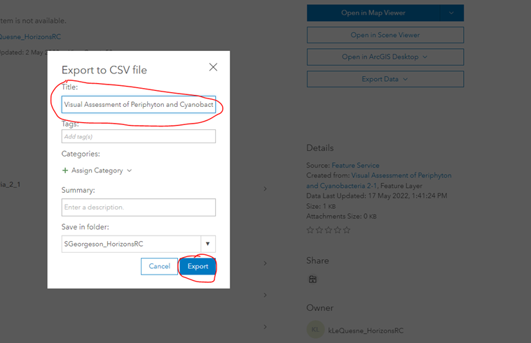

Once exported, you will be able to find the download option directly from the "content" tab in the white banner at the top of the page.

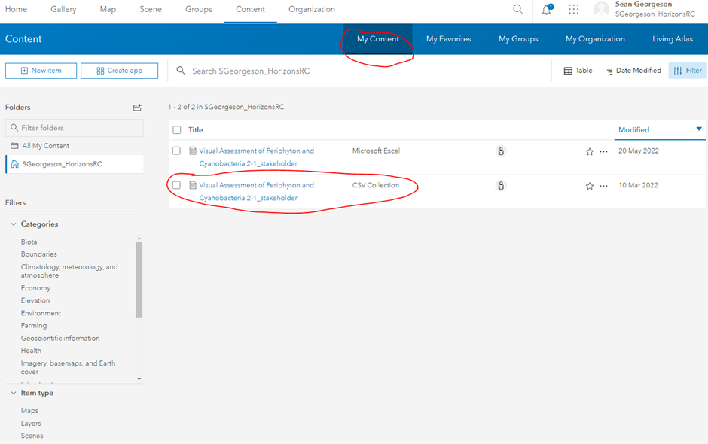

1. Export the data and the menu will change, now select “Download” (This will create a zip file of the visual assessment of periphyton information).

Overview 
Usage 
Download 
Update 
Share 
Metadata 
Setti ngs 

 The zip file should contain the following information for you to access:

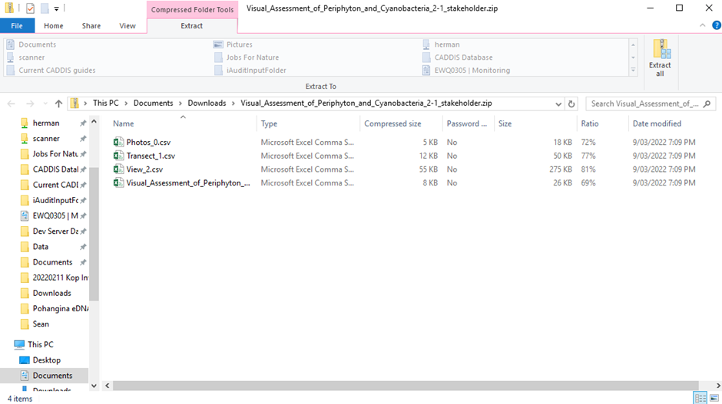

Extract all and save to \\file\herman\D\SR\03\01\Periphyton\Periphyton Data\Periphyton Survey Data\Downloaded from AGOL. In a new folder (named as date in format: year/month/day e.g 20220520)

## Accessing Periphyton photos:

Site photos are automatically pulled via a nifty Luke tool and stored into this folder system:

\\file\herman\D\SR\03\01\Water Quality\Admin\Site Metadata\Periphyton Sites\Photos

## Army ID process

For Moawhango at Waiouru we enter the Waiouru Defence Force Training area. Each month either the Friday or Monday prior to sampling, we call Range Control to see if we can sample on our sample day. Range Control oversee and organise all of the army training activities in the training area and they give us permission to enter. If permission is granted then we are able to sample on our proposed sampling date and if permission is denied then we try and arrange another sample time within the month.

Range Control phone number can be found in Teams <https://teams.microsoft.com/_#/tab::c7f095de-f312-433b-b78c-5cac0f05d22b/General?threadId=19:6dc901ead6384c909351b43c24f29f59@thread.tacv2&ctx=channel>

Part of the requirements of entry is that we need to be Blinds Trained by Range Control. You need to be blinds trained once before entering the training area so for any new staff make sure to arrange this when you are visiting.

We also arrange to have Defence Site Clearance (DSC) with DEI (Defence Estate and Infrastructure) who are another team that act as our sponsors (I.e. if anything untoward happens they are ultimately responsible for us). This is typically an ID card which is valid for 12 months and allows us to enter into the Defence force area without signing in at the front gate and without the need for an escort. The process for the Defence force ID card application/renewal is below:

Email [DEIWAISecurity@nzdf.mil.nz](mailto:DEIWAISecurity@nzdf.mil.nz) to get the correct documents.

Fill in the relevant documents (all forms of ID that are scanned are required to be signed off by a Justice of the Peace which is easily done at the PN District Court).

Send the relevant documents back to the email above with your next planned visit date and rough ETA so that hopefully you can get your ID card(s) printed while you are there.

Someone from DEI will respond and arrange a time to get your ID cards and explain the rest of the process from there.

**NOTE: It is important to begin this process approximately 1-2 months prior to your current ID expiry date to ensure that you don't need an escort when you arrive to do your sampling as this is a hindrance to both DEI and Range Control and is one of the reasons we were able to get ID cards in the first place.**

Application information is saved here \\file\herman\D\SR\03\01\Rivers\Periphyton monitoring\Moawhango at Waiouru Army ID

JP services at PN District Court <https://justiceofthepeace.org.nz/Page/Search?Location=palmerston+north&Surname=>  

# Periphyton Data

## Peri data 101

You need both the Survey123/field and chl-a/lab data to import the monthly results to KiEco.

Data requests are now done through KiEco, with three basic steps:

1) Getting the data from KiEco

2) Sense check and delete some columns

3) Attach metadata if it's missing, and send

There should be a lot of screenshots in this page, but if they're not loading, refer to here:

\\file\herman\D\SR\03\01\Rivers\Periphyton monitoring\Data Requests

## Getting Survey123/field data into KiEco

Log Into AGOL

<https://horizonsrc.maps.arcgis.com/home/item.html?id=cbd9c2e5a9ad4ca890464d6955e44ed5#overview>

Log in via cooperate log in – horizonsrc

If survey doesn’t show up log in using:

- Username :    ScienceBioMonitoring

- Password:     Fish\_are\_Friends\_2022

Visual Assessment of Periphyton and Cyanobacteria 2022\_stakeholder: Feature layer



Content

Export data:

Export to CSV

Save to

\\file\herman\D\SR\03\01\Rivers\Periphyton monitoring\AGOL\_Periphyton\_Download\Downloaded from AGOL

[\\file\appdata\Wiski\LIVE](file://file/appdata/Wiski/LIVE)

1)      The first is an Aquatic biomonitoring user log in. This one can view everything in the database and (I think) export data at a later date, but cannot edit anything:

**Username:** AB\_user

**PW:** Fish\_are\_Friends\_2022

2)      The second is aquatic biomonitoring data admin. This user can view all data but only edit the aquatic biomonitoring data (i.e. they can’t accidentally edit the EcoBase biodiversity data).

**Username:** data\_admin\_ab   
PW: 2022\_Just\_Keep\_Swimming

* Kieco tools
* Prepare data for entry
* Monthly periphton Monitoring
* Field Data
* Copy where the months data is stored e.g.

\\file\herman\D\SR\03\01\Rivers\Periphyton monitoring\AGOL\_Periphyton\_Download\Downloaded from AGOL\Periphyton\_2024\_-\_October

* Select the corresponding files that each tab is asking for
* Enter the correct month for data to be entered
* Hit submit

[\\file\herman\D\SR\03\01\Periphyton\Periphyton Data\Data entry Peri.docx](file://file/herman/D/SR/03/01/Periphyton/Periphyton%20Data/Data%20entry%20Peri.docx)

## End of year

New Projects:

ADMIN MUST DO - LUKE

## Getting chl-a/lab data into KiEco

Chl-a data arrives from the lab each month via the Portal, and needs to be QCed, pre-processed and entered into KiEco for secure storage.

Saving the lab data

The lab email should come with a PDF, a CSV and a text file. Save each of these in the relevant year and month here: \\file\herman\D\SR\03\01\Rivers\Periphyton monitoring\Periphyton Sample Results\2024\Need to be entered" folder.

Quality checking

Open the PDF, CSV and text files, and check these things:

1) The sample months are the same, e.g. all the samples were collected in September;

2) Both Mg/L and micrograms per sample measures are available for all the samples;

3) The site names and sample dates make sense, e.g. two peri sites on Lower Rangitikei day have the same sample date;

4) The chl-a values are the same between the text file, PDF and CSV for around 10 random samples. Make sure you compare the right chl-a units with each other, e.g. Mg/L with Mg/L;

Cust Lab Si Lab Sample Description 
HORIC444± Ohau at Gladstone Reserve 
HOR C444" Ohau at Gladstone Reserve 
Sample Name 
HRC2023WQU00579 
HRC2023WQU00579 
Sam led date 
10/07/2023 0: 
10/07/2023 0: 
Rec R 
Result 
Units 
1500 micrograms per sample 
11 mg/L 
Commen 
Review Date 
14/08/2023 10:17 
14/08/2023 10:17 

ysisNotes I LabSampID I Samp1eNotes I SiteID I Samp1eID 
e I Samp1eDate I Matrix I LabMethodID I Resu1tNotes I AnalysisDate I AnalysisBy I DataResu1t I DataQua1ifier 
IOhau at Gladstone ReservelHRC2û23UQUûû5791 
8/87/2823 MATICHLA 961,1ELLl 189/88/2823 SUMALINlCh10rophy11 al 

Laboratory ID: 
Description: 
Customer ID: 
Analysis 
Chlorophyll a 
Chlorophyll a 
C44434-1 
Sample Type: 
Algal Mat 
Units 
pg/sample 
mg/L 
Date Sampled: 
Date Received: 
10/07/2023 
03/08/2023 10:10 
Ohau at Gladstone Reserve 
HRC2023WQU00579 
Result 
1500 
11 
Method 
NIWA Periphyton Monitoring Manual (mod.) 
By Calculation 

After you confirm the data matches itself and makes sense, you can pre-process it for KiEco.

Pre-processing lab data for KiEco

1) Go to KiEco Tools (<http://tqm.horizons.govt.nz/Hydrology/Science/dashboard_map.html)>, and select "Prep data for entry"

Home 
Biodiversity 
Aqua Biomanitaring 
Prepare Data far Entir 
KiECO Tools (KiT) 
Welcome to 
This app is designed to help you 
There are currently three sub-pag 

2)

Chl-a:

5) lab csv will be saved here: \\file\herman\D\SR\03\01\Rivers\Periphyton monitoring\Periphyton Sample Results\2024\Need to be entered

6) lab csv is put through KiEco Tools on <http://tqm.horizons.govt.nz/Hydrology/Science/dashboard_map.html> ("Prep data for entry")

[\\file\appdata\Wiski\LIVE](file://file/appdata/Wiski/LIVE)

1)      The first is an Aquatic biomonitoring user log in. This one can view everything in the database and (I think) export data at a later date, but cannot edit anything:

**Username:** AB\_user

**PW:** Fish\_are\_Friends\_2022

2)      The second is aquatic biomonitoring data admin. This user can view all data but only edit the aquatic biomonitoring data (i.e. they can’t accidentally edit the EcoBase biodiversity data).

**Username:** data\_admin\_ab   
PW: 2022\_Just\_Keep\_Swimming

## Getting peri data out of KiEco

1) Go to KiEco Tools: <http://172.29.100.109:8515/>

2) Select Aquatic Biomonitoring, and then click on 'GET SITE DATA':

x 
Home 
Biodiversity 
Aquatic Biomonitoring 
Prepare Data far Entir 
KiECO Tools (KiT) 
Please get in touch if you find a bug! 
GET SITE DATA (click me!) 
GETTAXA INFO (click me!) 
The GET TAXA INFO function allows the user to view the fu 
Outputs from this function are sites and dates at which seL 

3) The periphyton programme is set up each year as its own thing, e.g. Periphyton 2008, Periphyton 2015. Therefore, you have to select all the periphyton programmes for the years you want data for. Remember the periphyton year runs December to November, so December 2020 will be in the Periphyton 2021 programme, while December 2021 will be in the 2022 programme. Tick the box for all the periphyton programmes you want, and click "update" when you're happy. You might have to scroll through the programme list (arrow, bottom right in the red circle below) to get to the periphyton programmes.

Step О: Choose monitoring programs. 
The table below contains the monitoring programs in kiECO. 
Before progressing to the data extraction step, please select апу programs уои аге interested in using the checkbox оп the left of the table. 
Опсе уои are happy with your selection please press the ”update” button at the top left of the table to proceed. 
Upd&te 
[2 
[2 
[2 
[2 
[2 
[2 
[2 
[2 
[2 
[2 
[2 
[2 
MonitoringProgramme 
Lake SampIing 2015 
Lake SampIing 2017 
Lake SampIing 2018 empli... 
Lake SampIing 2019 
Lake SampIing 2020 
Lake SampIing 2021 
Lakes SampIing 2022 
Lakes SampIing 2023 
New Queey Test 
Croua ]nvestigatizn 
емот test 
Реп te 
2008-200 
2002-2010 
Periphyton 2010-2011 
Mon'tor'ngProgrammeHRC... 
+RC2C16 006 
+RC2C17 006 
006 
+RC2C1g 006 
+RC2C20 006 
006 
+RC2C22 006 
+RC2C23 006 
TST202D 002 
008 
TST202D 
TsT2017 СОД 
+RC20Dg 002 
+RC2C10 002 
002 
StudyAreaName 
+o.•izzns - Aquatic Bizmznitzri... 
+o.•izzns - Aquatic Bizmznitzri... 
+o.•izzns - Aquatic Bizmznitzri... 
+o.•izzns - Aquatic Bizmznitzri... 
+o.•izzns - Aquatic Bizmznitzri... 
+o.•izzns - Aquatic Bizmznitzri... 
+o.•izzns - Aquatic Bizmznitzri... 
+o.•izzns - Aquatic Bizmznitzri... 
+o.•izzns - Aquatic Bizmznitzri... 
+o.•izzns - Aquatic Bizmznitzri... 
+o.•izzns - Aquatic Bizmznitzri... 
+o.•izzns - Aquatic Bizmznitzri... 
+o.•izzns - Aquatic Bizmznitzri... 
+o.•izzns - Aquatic Bizmznitzri... 
+o.•izzns - Aquatic Bizmznitzri... 
22 
2 of7 
Number of selected rows: о 

4) Next is selecting the sites. Choose how you want to select your sites. "From a list" is probably the easiest, but maps and shapefiles are also an option.

Step 1: Finding sites of interest. 
How would you like to select your sites? 
o 
o 
o 
Please choose an option below 
From a list of all sites 
From an interactive map 
From a shape file on the HRC-network 

Tick the sites you want, and click "update". Again, you might have to go through a few screens to get to all the sites:

Step 2: Select specific sites and outputs of interest. 
The table below contains the sites you have selected for viewing. 
Before progressing to the data extraction step, please double check your selection, and deselect any sites you are not interested in, using the checkbox on the left of the table. 
Once you are happy with your selection please press the "update" button at the top left of the table to proceed. 
Update 
SampleAreaCode 
Almadale 
Apiti Gorge_Bridge 
Awahuri_8ridge 
Gladstone Reserve 
Ha mua 
Hopelands_Reserv'e 
Horseshoe bend 
Mais Reac 
Makotuku Raetihi 
Makotuku 
Makotuku as STP 
Makotuku us STP 
Manawatu PNCC STP 
Manawatu us PNCC STP 
Mangaatua_DS Woodvile... 
Number of selected rows: O 
SampleAreaLongName 
Oroua at Almadale 
Croua at Apiti Gorge 
Croua at Awahuri Bridge 
Chau at Gladstone Reserve 
Makakahi at Hamua 
Manawatu at Hopelands 
Tokomaru at Horseshoe Bend 
Pohangina at Mais Reac 
Makotuku at Raetihi 
Makotuku at SH4g 
Makotuku d/s Raetihi STP 
Makotuku o/s Raetihi STP 
Manawatu d/s PNCC STP 
Manawatu o/s PNCC STP 
Mangaatua S/s Woodville STP 
Monitoring ProgrammeHRC... 
HRC2011 002 
HRC2C11 002 
HRC2C11 002 
HRC2C11 002 
HRC2C11 002 
HRC2C11 002 
HRC2C11 002 
HRC2C11 002 
HRC2C11 002 
HRC2C11 002 
HRC2C11 002 
HRC2C11 002 
HRC2C11 002 
HRC2C11 002 
HRC2C11 002 
geo met ry 
POINT( 175.6585798 -40.17318... 
-1 
POINT( 175.92619667 -39986... 
POINT( 175.52147052 -40.2754... 
POINT( 175.33527956 -40.6629... 
POINT( 175.74648232 -40.5653... 
POINT( 175.96045869 -40.3608.. 
POINT( 175.52726507 -404896... 
POINT( 175.78293721 
-402235... 
POINT( 175.28187718 -394222... 
POINT( 175.32630986 -39.3702... 
POINT( 175.28658952 -3943"... 
POINT( 175.28555423 -39ß377... 
POINT( 175.58399028 -40.3948... 
POINT( 175.59592187 -40.3843... 
POINT( 175.84634386 -40.3464... 
Itc IS of 57 
Page I of C 

5) Finally, select your outputs. Untick "output map" if you don't need one (you probably don’t for a data request), and make sure "output site data" is selected (third option down). You can enter your start date if you want, but you'll only get data from the programmes you selected earlier. Then click on "finished, get my data" below the end date.

Step 3: Select outputs and get data. 
STATUS: 
C) Output map of selected sites 
Waiting for user selections. 
C) Output shape file of selected sites 
e Output site data 
Note: you can ignore the date inputs below if you are not getting site data. 
Please enter the starting date range for data retrieval. 
1980/01/01 
Please enter the end date range for data retrieval. 
2023/10/27 
Finished, please get my data! 

The tool will run and pull the data from KiEco. You'll know it's running when the symbols in the top right change, and the "finished" button is red. You can see the progress in the left hand area under "status". You can stop the process by clicking "stop" in the upper right hand corner:

RUNNING„ 
Number of selected rows: 1 
Step 3: Select outputs and get data. 
STATUS: 
C) Output map of selected sites 
Data extraction started... 
C) Output shape file of selected sites 
Working on site data. 
Samplings to go: 15 
e Output site data 
Note: you can ignore the date inputs below if you are not getting site data. 
Please enter the starting date range for data retrieval. 
1980/01/01 
Please enter the end date range for data retrieval. 
2023/10/27 
Finished, please get my data! 
Stop 

The tool is finished when the "download data" button appears in the bottom left, and you get a time in seconds under the "finished, get my data" button. Click on the "download data" button, and you should start downloading a zip file to your downloads.

Step 3: Select outputs and get data. 
STATUS: 
Data extraction started... 
FINISHED! Please press the button below to 
download your results files. 
Download data 
C) Output map of selected sites 
C) Output shape file of selected sites 
e Output site data 
Note: you can ignore the date inputs below if you are not getting site data. 
Please enter the starting date range for data retrieval. 
1980/01/01 
Please enter the end date range for data retrieval. 
2023/10/27 
Finished, please get my data! 
14.532400608062744 seconds 

6) The data will download as a zip folder to your downloads. Copy this to the data request working folder, and rename it with the date, data request info (module id) and something like "raw\_peri\_data". This info should be available from the data request folder that Luke makes. Extract the files to the folder:

Compressed RA_working 
x 
Home 
Share 
Copy path 
Rn to Quack Copy Paste 
Move Copy Delete Rename 
access 
Paste shortcut to • 
New 
folder 
Clipboard 
Organize 
•A Open • 
Easy access • 
Properties 
Open 
A « 2023 ecological RA_working 
all 
Select none 
Invert selection 
Select 
Search PA_wcrking 
Fish 
older 
cwheeler Muserhome\usersS) (M:) 
This pc 
Desktop 
Digital Still Camera 
Downloads 
Music 
Picture 
Videos 
ZonTH.15301 
'wheeler muserhome\usersS) 
tktwork 
I item I it select ed KB 
Date d 
24/10/2023 AM 
Type 
20230911_122124 WWTP 
Open in Window 
Scan for threats 
Pin to Start 
Open 
Rest ore 
Send to 
Rename 
Properties 

E ( on $ ( z d ) Fo | d 
Select a Destination and Extract Files 
Fileswillbeemactedtothisfolder: 
\ ( On n \ T , a 丨 一 Environn nt 0 \ 20 811 」 4 VTP \ 0 | 09k 
0w3 , dfil when ( omp ~ 
B 「 ow , , , 

7) Check that the KiECO results spreadsheet is in the newly extracted folder, and rename it with the date, data request info and "periphyton":

Home 
Share 
View 
Copy path 
Pin to Quick Copy Paste 
Move 
o 
Copy 
Delete 
Organize 
Rename 
access 
-0 Easy access • 
New 
folder 
open • 
Edit 
Properties 
Open 
Select all 
Select none 
Invert selection 
Paste shortcut to 
Clipboard 
20230911_122124 ecological 
RA working 20230911_122124 RawPeriData 
Fish monitoring 
Caitlin_working_folder 
cwheeler (M:) 
Didymo 
RemoteApps Base 
Name 
20230911 
20230911_ 
122124 WWTP RawPeriDatazip 
122124_periphyton.xIsx 
Date modified 
24/10/2023 AM 
24/10/2023 AM 
Type 
Compressed (zipp... 
Microsoft Excel W... 
Select 
Search 20230911 122124 
Size 
305 KB 
305 KB 

 Leave the original zip folder in the data request folder (just make sure it's associated with the data request and not in your personal drive that no-one else can access).

## Preparing peri data requests

Your extracted KiEco data spreadsheet should have eight tabs (maybe 9 if there's another metadata tab included):

Site metadata 
Site spatial location 
Sample metadata unit and Spot Data 
Chlorophyll a 
Sediment 
Substrate 
Periphyt 
on cover 

1) Open the spreadsheet, and check that the correct site names are in the "site metadata" tab. You should have repetitions of site names if you're taking from multiple years of data, because you're technically querying multiple periphyton programmes. Delete any duplicates to provide a neat summary of the contained sites:

2 
4 
site name 
Oroua at Almadale 
Oroua at Almadale 
Oroua at Almadale 
Hilltop site name 
Oroua at Almadale Slackline 
Oroua at Almadale Slackline 
Oroua at Almadale Slackline 
Site type 
River 
River 
River 
Delete 
Delete 
C) Shift cells left 
C) Shift cells up 
@ Entire cow 
C) Entire column 
Cancel 

2) Check the site spatial location is there for all the sites you've downloaded. There shouldn't be any site name duplicates here. If there are, compare the coordinates and notify Luke or Ian if they are different between the sites.

3) Click on the "Unit and Spot Data" tab, and set a filter (ctrl + shift + L) on the "spot" column. If it's entirely empty, you can delete this column ONLY IN THIS TAB. Remove the filter after you're done.

ałdłu 
gduad 
gduad 
gduad 
gduad 
gduad 
gduad 
gduad 
gduad 
gduad 
gduad 
gduad 
gduad 
gduad 
gduad 
gduad 
gduad 
gduad 
gduad 
gduad 
gduad 
Sunn 
uun 
'aqwnN 
M ałq 
ałqea 
pasu e 
4uawu6!lV 
ap ald 
enouo 
(syługłg) 
pałas) 
qD'2as 
Jea15 
'0100 
eu au 
mu!ed 
oz 
61 
81 
OL 
6 
8 
g 
wds 
wog 
luauao 
. muaD a5'aL,N 
uał de] M 
"'OP acu 
sełnuuo± a5ed 
vasuł 
aVed 
ałuoH 

4) Click through the other tabs to make sure data is there. Check that all the site names and years are there (don't worry about every date and time). You can use the filter function to do this quickly, just remove the filters after you're done. You can also expand all the columns so that it looks nicer.

5) On the chlorophyll-a tab, filter by "units" (ctrl + shift + L) and then look through the data value numbers for each unit to see if the numbers are relatively similar/sensical. You can also highlight them all with your cursor and check the mean isn't crazy. If you get a high result (e.g. 3000 mg/L), check the views data or the chl-a of a paired site (e.g. u/s and d/s of an STP) to see if the number makes sense for that sampling instance. If there are crazy numbers, tell Ian and you can check the other data to see if the value makes sense. Remember to remove the filter once you're done (ctrl + shift + L).

2 
e 
o 
o 

6) The final steps are attaching the metadata and preparing the disclaimer. If there's no "Welcome" tab, add a new tab, drag it to the far left before all the others and rename it to "Welcome". Copy this spreadsheet into the Welcome tab (click on the red circled arrow below and press ctrl + c):  [\\file\herman\E\WQ\03\05\Periphyton monitoring\Data Requests\2023\_KiEco\_metadata.xlsx](file://file/herman/E/WQ/03/05/Periphyton%20monitoring/Data%20Requests/2023_KiEco_metadata.xlsx)

MAKE SURE YOU AREN'T PASTING OVER DATA.

7) Fill in your name, the time range the data covers (e.g. May 2021 - May 2023), and copy in the site names to the Welcome tab:

2 
6 
Data compiled by 
Time range of the data 
NOTE 
Site Locations 
Homer Simpson 
May 2021-May 2023 
Oroua at Almadale 

Save your periphyton data spreadsheet.

8) You will also need to fill in a ‘data disclaimer’ sheet and save this in the same file path that the data request has been saved. This just lets the requester know that the data we have provided is true to the best of our knowledge and we cannot be held liable if it is not true.

The disclaimer is saved here: [\\ares\Environmental Data Requests\1\_Request Template\Disclaimer Supply of Environmental Data\_SmallRequests.docx](file://ares/Environmental%20Data%20Requests/1_Request%20Template/Disclaimer%20Supply%20of%20Environmental%20Data_SmallRequests.docx)

This document is for small data requests only and large periphyton requests use a different disclaimer. You only have to fill out the person who has completed the request and where you got the data from. The date should auto fill.

For "source", type "KiEco".

To get the request ID, click the back arrow in Portal:

Edit 
Close 
Chla data 
Created by Luke Fullard on Jul 31, 2023 10:43 AM 
Details 
Task Details 
Group 
Task Dependency 
Worklogs 
Comments 
History 
Not Assigned 

Or click on the data request (you’re most likely just working on a task within the data request):

Actions v 
Request » Task 
Status 
Owner 
Priority 
Task Type 
Attachments 
Progress 
Task Order 
% Completed 
Task < 
Open 
Caitlin Wheeler 
Not Assigned 
Not Assigned 
NO due date set 
R uest 
Re: [Request ID : Pahiatua & 
etahuna WWTP Data request 

And then copy in this number:



9) Update the footer file path in the disclaimer document with the one for the data request:

10) Save a copy of the disclaimer in the data request folder you're working in, and then export it as a PDF to the same folder. You should end up with two versions, but we only send the PDF:

) NZDF 2 1072 11 37W · ~ , STP ) p , ♂ on 
Disc 3 p Of E 哥 : 一 0 
11 、 20 1 59 PM Adobe Acrobat : 
11 、 2023 12 二 3 PM M 0 Word D„, 
11 、 20 11 “ AM Comp 「 p ! 
Da 30d ed 
2 
271 KB 
37 KB 

Save this in the file pathway that you have been given to save the data.

11) For sending data, refer to main data page (coming soon).

## Monthly KiEco import update?

2024 peri year:

AGOL data needs to be in KiEco before you can import the chl-a for any given month

## Survey 123 Connect

Survey 123 can only be edited in survey 123 connect. Connect can only be used on a PC or a VPN laptop and not via the farm.

Log in using the shared account:

ScienceBioMonitoring

Fish\_are\_Friends\_2022

This will give you access to the published surveys that this account owns (unpublished surveys are only accessible on the device that they were created on).

Open the survey that needs editing and then on the left-hand side open the XLSForm this will bring up an excel spreadsheet.

– if just adding/taking away names just go into the choices tab

- In the choices tab next to CollectedBy follow the same naming as the other columns and just insert new names.

- simple changes can be done with an update to the survey (must republish the survey after any edits).

- Changes to the survey tab will mean that a new survey will be published – avoid making changes like this unless necessary for data collection. Make sure the changes that are made and the new survey published is sorted for the new sampling month (DO NOT split the month onto multiple surveys)

- Google is your best friend when creating and updating surveys. Arc GIS and forms are useful for solving problems that aren’t working. Craig Beven from Hydro has created the WQ surveys so is able to help if any problems arise.

[ArcGIS Survey123 Resources | Tutorials, Documentation, Videos & More](https://www.esri.com/en-us/arcgis/products/arcgis-survey123/resources)

[Guided tour—ArcGIS Survey123 | Documentation](https://doc.arcgis.com/en/survey123/desktop/create-surveys/createsurveys.htm)

QA Periphyton Transect Data Procedure

# Purpose

From the Periphyton surveys, the survey data is stored within Survey123 then is transferred into KiECO for analysis and storage purposes. Quality Assuring (QA) is done as it highlights the quality of the raw data, if quality down-coding is needed and if the data has downloaded in KiECO correctly.

This procedure outlines how to download HRC Periphyton Transect data from Survey123 and KiECO and then Quality Assure.

[\\file\herman\D\SR\03\01\Periphyton\QA\2024\_QA\_PeriData\_Procedure.docx](file://file/herman/D/SR/03/01/Periphyton/QA/2024_QA_PeriData_Procedure.docx)

Luke has made a nifty tool to merge

## Merging Survey 123 files

1. Open hilltop tools: [Hilltop tools (HiT)](http://172.29.100.109:8520/). (You must be using the farm for the app to work – cant access of VPN laptops (yet)).

1. Using Survey 123 csv merge drag and drop the files from the survey 123 dowload in the corresponding dropbox and patiently wait for it to run.

1. Making sure that the results data length and final merged data length numbers are the same, and the number of sites (form data length) is correct.

## 2.4 Merged document

1. Open the document and proceed to tidy up
2. Hide all random tabs

It should look like this:

# Quality Assuring the Data

Quality Assuring (QA) is the process of double checking the data, in this case, found in Survey123 with the data found in KiECO and ensuring the content is the same.

1. Randomly choose 7 surveys within the month you’ve filtered. When you click a survey, the survey form will pop up and you can use that form to compare to your KiECO excel spreadsheet.
2. It is always good practice to check the sample name, date and time first then ensure the rest of the data matches correctly.
3. Record the 7 surveys using an excel spreadsheet noting the Sample ID, Sample name, date/time and any issues found.
4. Filter the most common issues – total periphyton (100% no data + full transects), wadeable widths, transect depths, reach length, exposed detached selections
5. If 7 surveys within the month as passed with no issues then move onto the next month. If there are issues then the rest of the month has to be QA’d.
6. Once completed, send the QA excel spreadsheet to the Biomonitoring Scientist and/or a senior Data Analysist.